Ann Visger Preparatory Academy
School Supplies
Kindergarten  1 12” inch ruler  1 Blunt scissors  1 Box of #2 Pencils  2 Boxes of Tissue (wishlist item)  2 Box of Crayons  1 Dry Erase Markers Set  4 Glue Sticks  1 Large Pink Eraser  1 Pencil Case  6 Pocket Folders  3 Spiral Notebooks  1 Hand Sanitizer  1 Head phone set | 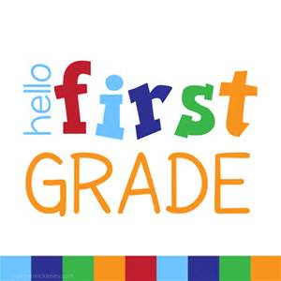  First Grade  1 Blunt scissors  1 Box of #2 Pencils  2 Boxes of Tissue (wishlist item)  1 Box of Washable Crayons  1 Dry Erase Markers  4 Glue Sticks  1 Large Pink Eraser  1 Pencil Case  6 Pocket Folders  3 Spiral Notebooks  1 Hand Sanitizer  1 Large Gallon Zip Lock Bags  1 Sandwich (size) Zip Lock Bags  1 Clorox Wipes (wishlist item)  1 Head phone set
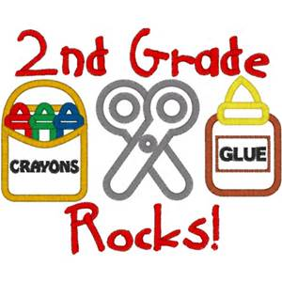  Second Grade  1 12” inch ruler  1 Blunt scissors  1 Box of #2 Pencils  1 Pencil Sharpener with Capturing Case  2 Boxes of Tissue(wishlist item)  1 Box of Crayons  1 Dry Erase Markers Set  4 Glue Sticks  1 Large Pink Eraser  1 Pencil Case  4 Pocket Folders  3 Spiral Notebooks  2 Composition Notebooks  1 Hand Sanitizer  1 Head phone set | Third Grade  1 12” inch ruler  1 Blunt scissors  1 Box of #2 Pencils  2 Boxes of Tissue (wishlist item)  1 Box of Crayons  1 Wide Line Paper  1 Hand Sanitizer  1 Dry Erase Markers Set  4 Glue Sticks  1 Large Pink Eraser  1 Pencil Case  6 Pocket Folders  3 Spiral Notebooks  1 1 to 1 ½ Inc. Binder  1 Pencil Sharpener with Capturing Case  1 Head phone set
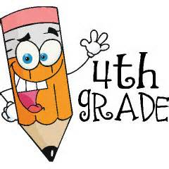  Fourth Grade  1 12” inch ruler  1 Blunt scissors  3 Box of #2 Pencils  2 Boxes of Tissue(wishlist item)  1 Composition Notebook  1 Dry Erase Markers and 4 Glue Sticks  1 Hand Sanitizer / 1 Clorox Wipes (wishlist item)  1 Large Pink Eraser and 1 Pencil Case  6 Pocket Folders  1 Headphones for Computer Lab  4 Spiral Notebooks (blue, red, green, yellow) | 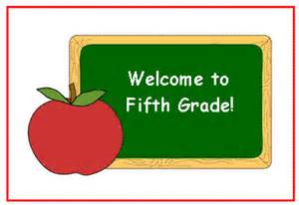  Fifth Grade  1 12” inch ruler  1 Blunt scissors  3 Box of #2 Pencils  2 Boxes of Tissue (wishlist item)  1 Composition Notebooks  1 2 in-Binders  1 Dry Erase Markers and 4 Glue Sticks  1 Large Pink Eraser and 1 Pencil Case  6 Pocket Folders and 6 Spiral Notebooks  1 Hand Sanitizer / 1 Clorox Wipes (wishlist item)  1 Headphones for Computer Lab  1 Packs of Wide Line Paper

**Proper gym shoes and socks for Physical Education **Music Book, Reed, Drum Sticks (TBD)

